**Task a**

1. **Create** 4 files named yourID_1.txt, yourID_2.txt, yourID_3, yourID_4.txt and 2 directories named YourName1, YourName2.

**touch** 21201188_1.txt 21201188_2.txt 21201188_3.txt 21201188_4.txt

1. **Move** yourID_1.txt, yourID_2.txt, yourID_3.txt in YourName1 directory.

**mkdir** SartizAlamAyon1 SartizAlamAyon2

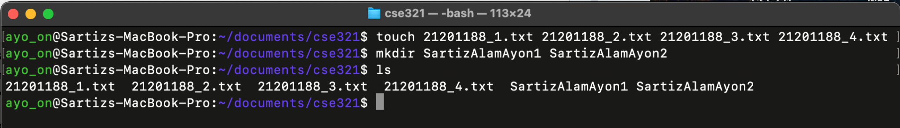

1. **Move** yourID_1.txt, yourID_2.txt, yourID_3.txt in YourName1 directory.

**mv** 21201188_1.txt 21201188_2.txt 21201188_3.txt SartizAlamAyon1

1. **Copy** yourID_1.txt, yourID_2.txt YourName2 directory

**cp** SartizAlamAyon1/21201188_1.txt SartizAlamAyon2

**cp** SartizAlamAyon1/21201188_2.txt SartizAlamAyon2

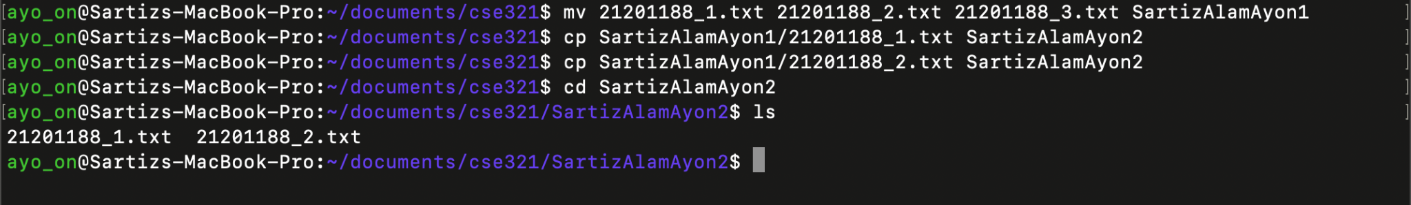

1. **Create** another directory YourName3.

**mkdir** SartizAlamAyon3

1. **Copy** the YourName1 directory along with its contents to the YourName3 directory.

**cp** -r SartizAlamAyon1 SartizAlamAyon3

1. **Go into** the YourName3 directory and check the permissions of the files/directory and change the permissions for both groups and others to only read-execute for all the files.

**cd** SartizAlamAyon3

**ls** -l

**chmod** -R g-w,o-w SartizAlamAyon1

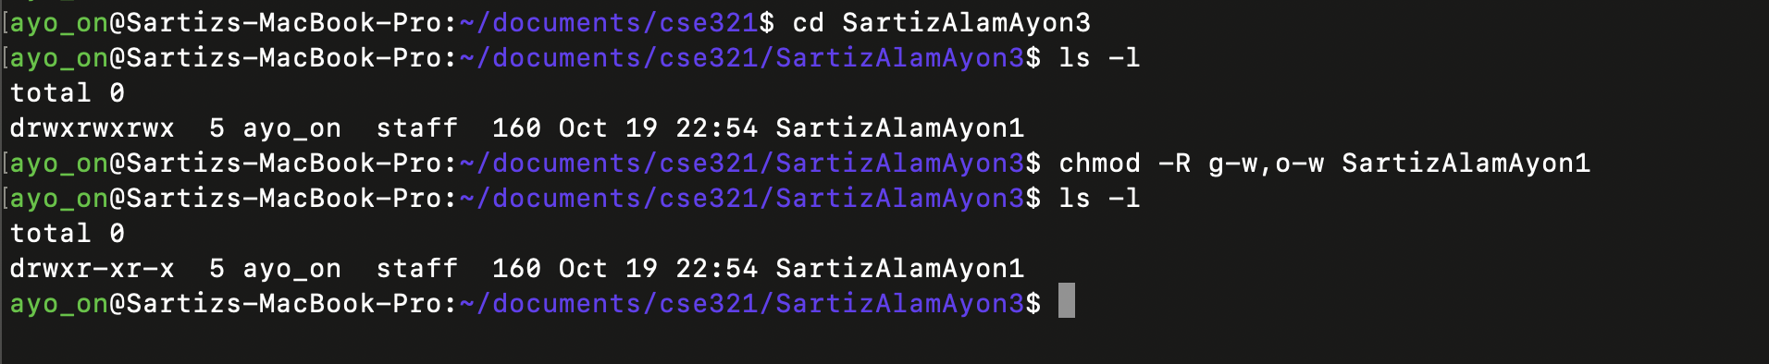

1. **Go back** to one directory and print all the directories and files in the current working directory

**cd** ..

**ls**



1. **Move** the YourName3 folder to the root directory and delete the rest of the files and folders in the current working directory.

**mv** /Users/ayo_on/Documents/cse321/SartizAlamAyon3 /Users/ayo_on/

**rm** -r 21201188_4.txt SartizAlamAyon1 SartizAlamAyon2

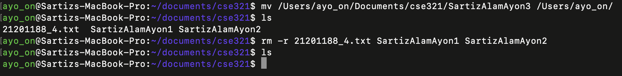

**Task b**

**Create** a file containing your running semester’s course information (course IDs, Course names, Sections, etc.) Count the lines containing the word “CSE” in that file named course.txt.

**cat** > courses.txt

**grep** -c "CSE" courses.txt

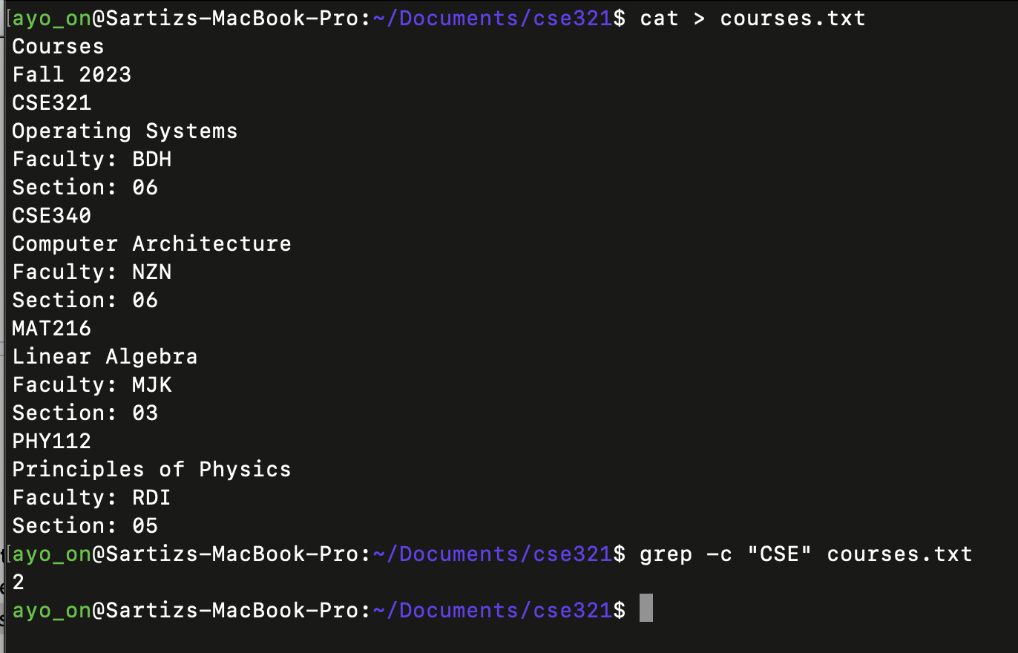

**Task c**

**Show** all the hidden files in your root directory.

**ls** -a

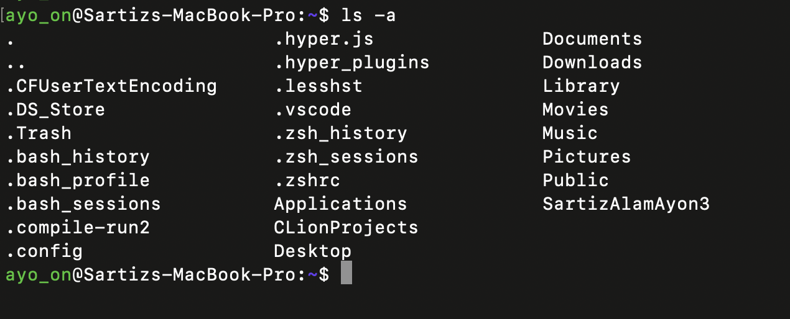

**Task d**

**Show** only lines 5-17 of a .txt file.

**sed** -n '5,17p' courses.txt

